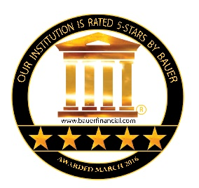

Media Release

FOR IMMEDIATE RELEASE: | CONTACT: | BauerFinancial, Inc.
 | TEL: | 1.800.388.6686
To the Editor: | FAX: | 1.800.230.9569
 |  | www.bauerfinancial.com
 |  | research@bauerfinancial.com

5-Star New Carlisle Federal Savings Bank
Forging Community Partnerships for 133 Years

March 2016: New Carlisle Federal Savings Bank, New Carlisle, Ohio is honored to announce it has once again earned BauerFinancial Inc.’s highest 5-Star Superior rating. A 5-Star rating indicates that New Carlisle Federal Savings Bank is one of the strongest banks in the nation, excelling in such areas as capital, loan quality, profitability and much more. New Carlisle Federal Savings Bank has earned Bauer’s recommended rating (either 5-Stars or 4-Stars) for 111 consecutive quarters.

Karen L. Dorway, president of BauerFinancial, recognizes that, “As market conditions continue to change, banking institutions must be adept enough to evolve with them. With New Carlisle Federal Savings Bank’s stellar financial condition and track record, we have no doubt in its ability to do so. The community is privileged to have such a strong financial partner in its midst.”

Established in 1883, New Carlisle Federal Savings Bank has been serving its neighbors for the past 133 years. Today it operates through three conveniently located branch offices in New Carlisle, Springfield and Tipp City and can also be found on the internet at newcarlislefederal.com.

New Carlisle Federal Savings Bank: “…more bank for your buck!”

Member of the FDIC and an Equal Housing Lender.

BauerFinancial, Inc., Coral Gables, Florida, the nation’s leading independent bank and credit union rating and research firm, has been reporting on and analyzing the performance of U.S. banks and credit unions since 1983. No institution can pay for or opt out of a BauerFinancial rating. Consumers may obtain free star-ratings by visiting bauerfinancial.com.

###

BauerFinancial, Inc. P.O. Box 143520, Coral Gables, FL 33114.

